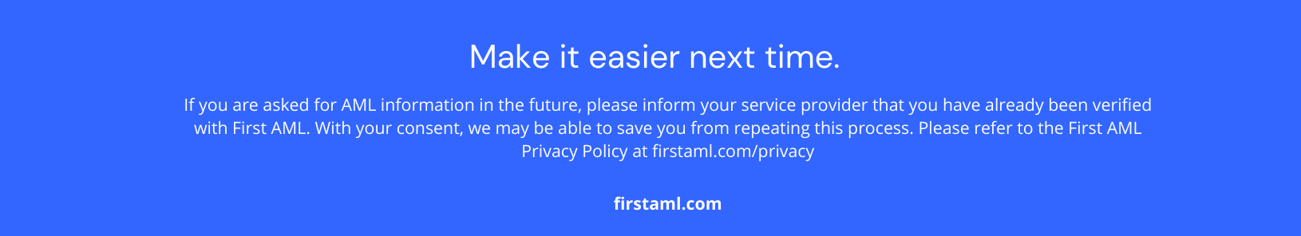
Who is First AML?

First AML is a specialist service provider that has been engaged on behalf of [Customer Name] to conduct Customer Due Diligence (CDD) on you or an entity you are associated with. Our local team of AML Specialists will be in touch to securely and discreetly collect identity information and complete the process.

This verification process is an important part of helping [Customer Name] to comply with anti-money laundering legislation requirements.

First AML helps 500+ global companies comply with these rules, with the goal of making the process as quick and easy as possible for their clients (you).

Obligations

To comply with the legislation, [Customer Name] must conduct CDD. This involves understanding ownership structures of their clients, whether they be individuals, companies or trusts. No matter the type, they must conduct identity verification on every associated individual.

That’s where you come in. In the case of companies and trusts, the associated individuals may be Directors, Shareholders, Trustees or Trust Beneficiaries.

How will your information be used?

Your information will be used for the sole purpose of conducting CDD and identity verification. Your information will remain confidential and will not be shared outside of First AML or [Customer Name] without your consent.

What will you need to provide?
Below is a list outlining the type of information you may be required to provide. We’ll confirm the exact requirements as we work through and verify the full entity ownership structure. We are required to verify every layer of the shareholding structure; therefore, additional information or documents may be requested as the structure is verified.
Guidelines for Source of Wealth and document certification will be provided.
- Individual Verification
  - Name
  - Date of birth
  - Address
  - ID document - Ideally, NZ/AU Passport or Driver's license
- Individual verification, where we are unable to verify your identity electronically
  - Certified passport OR certified licence AND secondary form of ID e.g. Birth certificate/ Certified Bank statement
- Sole Trader
  - NZBN Registration
- Private Company
  - Confirmation of whether there are any nominee directors/shareholders
  - Constitution (if applicable)
- Foreign Company with restricted company registry information, e.g. Cayman Islands
  - Certified Shareholding Structure Chart
  - Certified Certificate of Incumbency
- Unlisted Public Company
  - Certified Shareholding Structure Chart
- Partnership
  - Partnership Deed / Confirmation of Partnership
- Limited partnership
  - LP Deed
  - General partner - Nominee shareholding confirmation
  - Limited Partner with over 25% beneficial ownership will need to be verified.
- Trust
  - Trust Deed
  - Amendments (if applicable)
  - Source of Wealth
  - Statement & supporting documents OR a detailed letter from your lawyer or accountant
- Association/society (Incorporated)
  - Constitution
  - Meeting Minutes
  - Association Registration Number
- Association/society (Unincorporated)
  - Source of Wealth
  - Certified Constitution
  - Certified Meeting Minutes
- Fund (MIS)
  - ASFL
  - Fund Product Disclosure Statement
- Joint Venture
  - Joint Venture Deed
- Estate
  - Probate OR Death Certificate & Will
- Body Corporate
  - Certified Body Corporate Operational Rules
  - Certified Meeting Minutes
  - Certified Unit Register
- In certain circumstances, additional information may be required after the initial documents have been reviewed by our team
  - Source of Wealth OR Source of Funds
  - Confirmation of no changes to the entity structure

