[insert name]’s Anti-Money Laundering Policy and Information

We are committed to adhering to the UK Anti Money Laundering laws, which require us to obtain certain information about you and your organisation. Our partnership with First AML ensures your onboarding process will be as smooth as possible.

Every customer is subject to the same checks. We have a team dedicated to our compliance with the relevant legislation, who work with First AML to ensure the setup process is as quick & simple as possible.

Insert these images + our logo into your webpage:
Logos accessed here: logo
Images accessed here: image
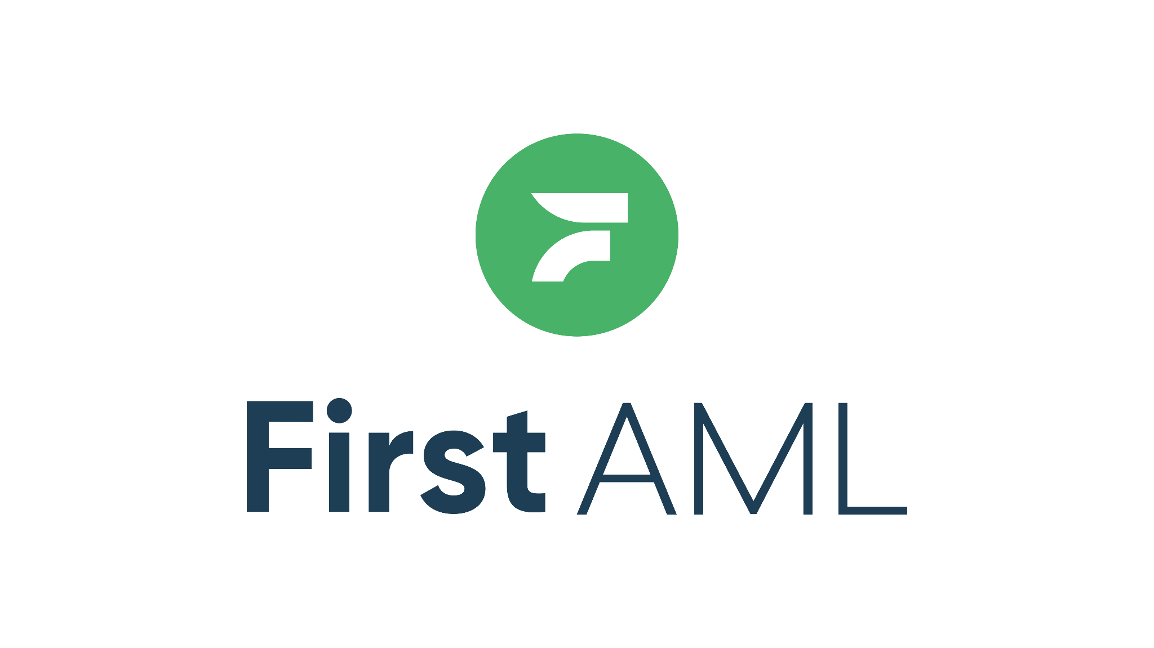
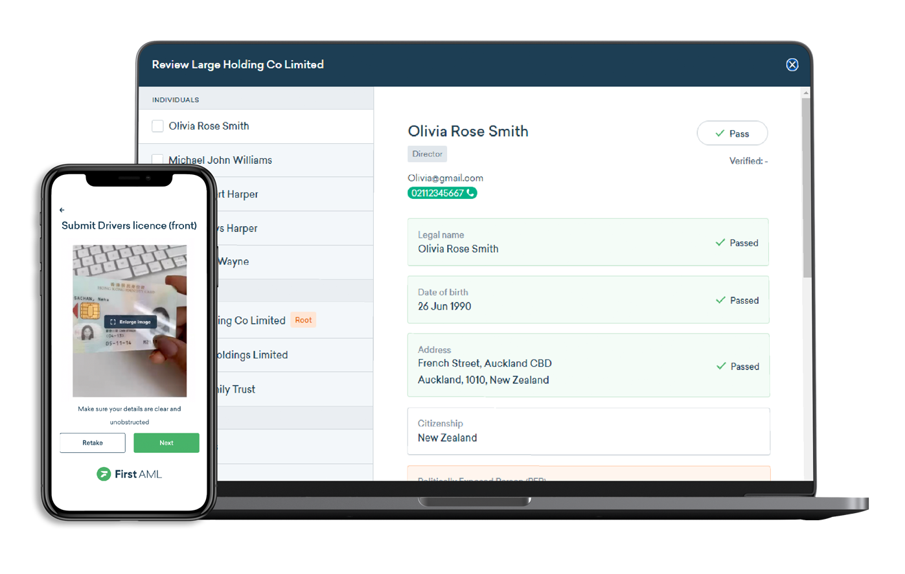

I’m getting contacted by First AML - who is this?
First AML are our partners in compliance. We have engaged them to conduct KYC checks on you or an entity you are associated with to ensure we are compliant with the relevant legislation. In addition, their local specialists may contact you to securely collect your identification documents and any other relevant personal information from you to verify your identity so that we can comply with the MLR17. Please send your information as requested to First AML to ensure we can activate your account as soon as possible.

They will email or text (SMS) you a link to an electronic verification form you must complete online.

If you have questions or want to contact First AML, check out their support page or the help centre.

[a button here with a link to our website - CTA “What is First AML?”]

Is my personal information safe with First AML?
First AML is a secure platform provider that collects your personal information and stores it in their Software Platform, where the data is held on AWS Servers based in Dublin. AWS is SOC 2 and ISO 27001 certified. First AML’s privacy and security measures are best in class, and they have also achieved ISO 27001 certification, are fully GDPR compliant and are an AWS Partner.

All data sent to First AML’s platform servers is transmitted over TLS for end-to-end encryption, with regularly updated cypher suites to ensure data privacy in transit. Once in the platform, data is stored encrypted at rest using regularly rotated encryption keys. First AML Developers also follow Secure Development practices and receive regular training.

Access to information is restricted to authorised parties who have a legal basis for information access (e.g. those who are conducting verification checks) and must meet the Information Security and contractual requirements. They ensure as few people as possible have access to your data.

How will my information be used?
Your information will be used for the sole purpose of conducting CDD/KYC and identity verification. Your information will remain confidential and not be shared outside First AML or [YOUR COMPANY NAME] without your consent.

Other FAQs
[insert First AML end user FAQs]
Take the wording and insert it into your FAQ section

